**Business Requirements Document for Dubshed webpage**

**Customer: http://www.dubshed.com/**

1. Display company logo on the left-hand side of the webpage



2.0 Display home page

2.1 Link to “watch last year’s video”

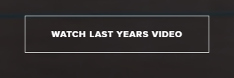

2.2 Link to buy early bird tickets

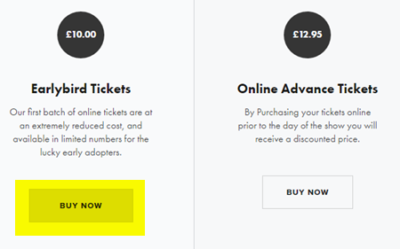

2.3 Link to buy advanced tickets

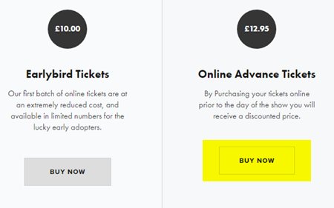

2.4 Link to enter your car

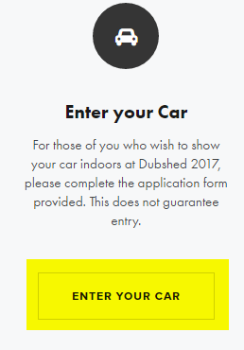

2.5 More about Dubshed links to about

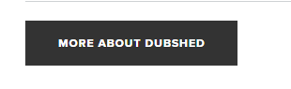

2.6 Link to get directions and same links as requirement 8.0

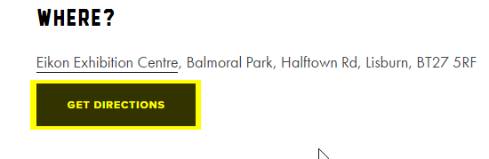

* 1. Links to sponsors (same as requirement 9.0)



3.0 Top left link to website Facebook page



4.0 Top middle link to website twitter feed



5.0 Top right link to website Instagram feed



6.0 Link to about page and return to home page by clicking on logo



7.0 Link to tickets page



7.1 Select from drop down how many tickets required

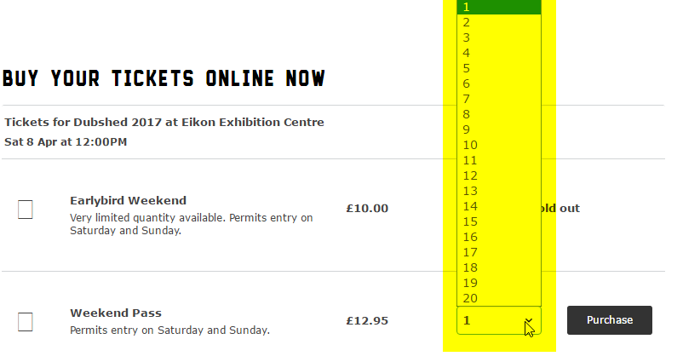

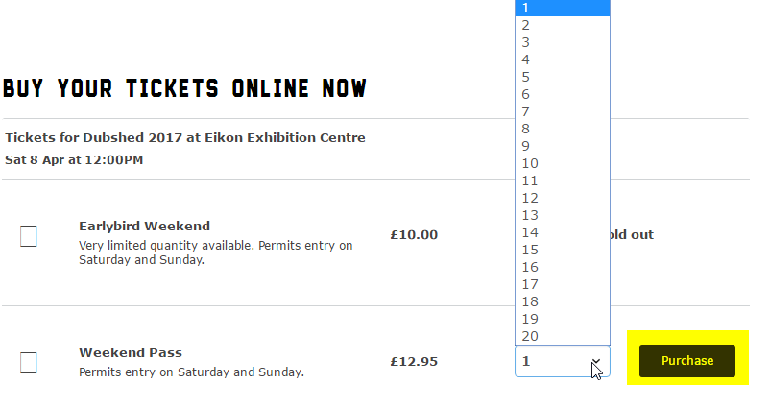 7.2 Click purchase

7.3 Enter details and continue to checkout

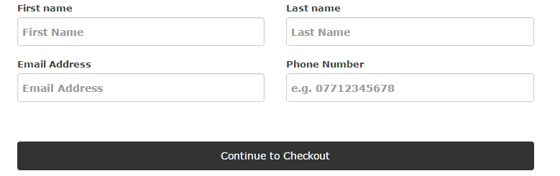

7.4 Enter card details and confirm payment

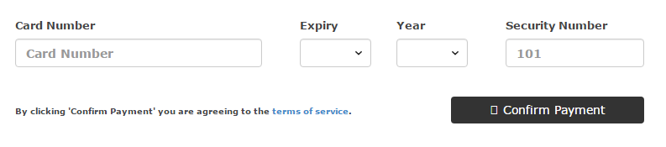

7.5 Return to home page

8.0 Link to What & where



8.1 Link to purchase tickets (same as requirement 7.0)

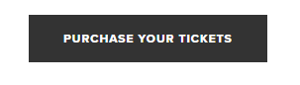

8.2 Map showing location and nearby hotels

8.3 Link to Eikon Exhibition centre web page



8.4 Link to Get Directions (Gives directions from my location in Google Maps)

8.5 Link to premier inn website

8.6 Link to Ballymac hotel website

8.7 Link to Ramada hotel website

8.8 Link to Radssion website

8.9 Link Jury’s inn website

8.10 Link to Ibis website

8.11 Link to travel lodge website

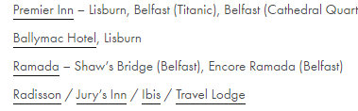

8.12 return to home page

9.0 Link to Sponsors



9.1 Link to [www.ilovebass.tv](http://www.ilovebass.tv)

9.2 Link to [www.autofinesse.co.uk](http://www.autofinesse.co.uk)

9.3 Link to [www.motorpartsni.co.uk](http://www.motorpartsni.co.uk)



9.4 Link to [www.airliftperformance.com](http://www.airliftperformance.com)

9.5 Link to [www.phillipsvolkswagen.co.uk](http://www.phillipsvolkswagen.co.uk)

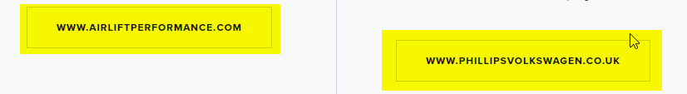

9.6 Return to home page

10.0 Link to Contact



10.1 Email link to [dubshed@gtini.com](mailto:dubshed@gtini.com)

10.2 General phone number link

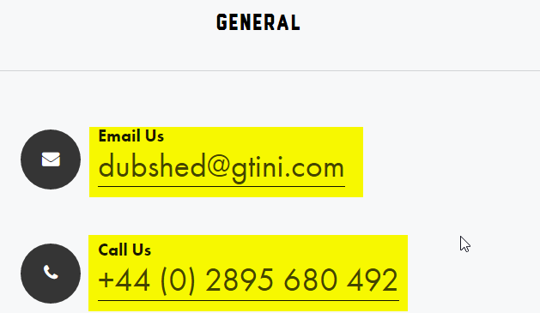

10.3 Email link to [traders@gtini.com](mailto:traders@gtini.com)

10.4 Traders phone number link

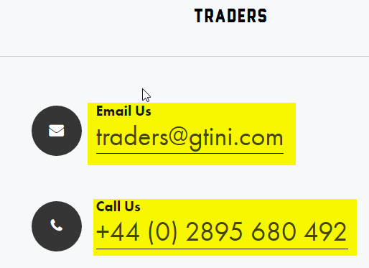

10.5 Return to home page

11.0 Link to forum and return to home page



12.0 Link to shop and return to home page



**BRD for DoneDeal login and sign up**

1.0 Home page displayed

2.0 Click login and login panel displays

2.1 Wrong email address/right password

2.2 Correct email address/wrong password

2.3 Correct email/correct password

2.4 Forgot password

3.0 Entering password

3.1 Wrong password/correct email

3.2 correct password/wrong email

3.3 correct password/correct email

3.3 Forgot password?

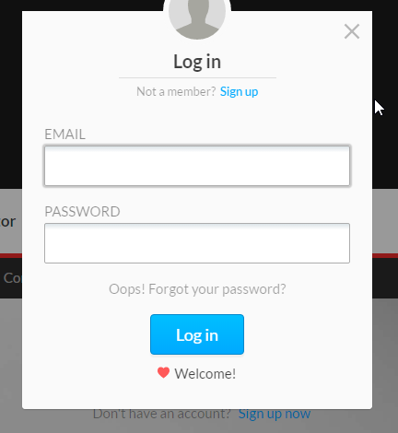

4.0 Sign up panel

4.1 email address

4.2 password

4.3 name

4.4 select county

